

SUPERIOR UNIVERSITY LAHORE
GOLD CAMPUS

NAME: MUHAMMAD MOIZ RAZA
ROLL NO: SU92-BSAIM-F24-061
PROGRAM: ARTIFICIAL INTELLIGENCE
SEMESTER: 4th SEMESTER
SECTION: BSAI-4A
SUBJECT: PROGRAMMING OF AI (LAB)

Submission Title: LAB TASK 10
Submitted To: Sir Rasikh Ali

TITLE: RULED BAS RESTURANT CHATBOT

Overview

This task is a simple Flask-based chatbot application designed for a restaurant system. The chatbot helps users by answering common questions such as menu items, prices, opening hours, location, ordering process, and other restaurant-related services. It works on a web interface where users type messages, and the system replies automatically using predefined rules.

Working
In this task, the user sends a message through a website, and Flask receives it in the backend. The chatbot checks the message using simple pattern matching (regex) from a predefined list. If it finds a match, it returns the related answer (like menu, timing, or order info). If no match is found, it gives a default reply like “Sorry, I didn’t understand.” The response is then sent back and shown on the screen.

USES OF CHATBOT
• Helps customers get quick restaurant information
• Provides menu details without needing staff
• Shares restaurant timings and location easily
• Assists in order tracking and reservation info

• Reduces manual workload for restaurant support

Advantages
- Easy to build and understand
- Works fast without heavy processing
- No need for AI or machine learning
- Simple structure using Flask and regex
- Can answer many common restaurant questions
- Easy to update or add new responses

Disadvantages
- Cannot understand complex or unclear questions
- Works only on predefined rules
- No learning or improvement ability
- Limited conversation flexibility
- Needs manual updates for every new query
- May fail if user writes unexpected input

SCREENSHOT
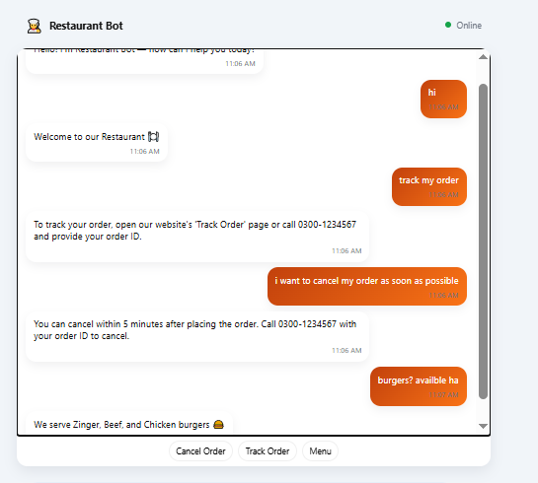

THE END

